● Na krivoj unesite na sta se odnose pomenute visine/dubine i ispod opišite na šta se odnose pomenute vrijednosti?
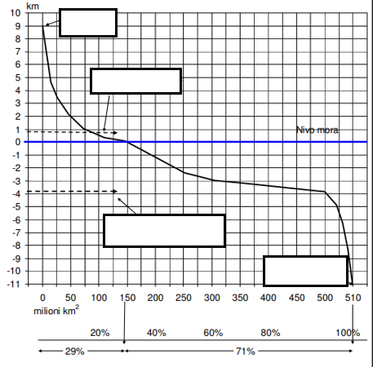
_______________________________________________________________________________________________________________________________________________________________________________________________________________________________________________________________________________________________________________________________________________________________________________________________________________________________________________________________________________________________________________________________________________________________________________________________________________________________________________________________________________________________________________________________________________________________________________________________________________________________________________________________________________________________________
● Šta predstavlja hipsografska, a šta batimetrijska kriva? _______________________________________________________________________________________________________________________________________________________________________________________________________________________________________________________________________________________________________________________________________________

● Opišite osnovne karakteristike morskog, glečerskog i rječnog leda: ________________________________________________________________________________________________________________________________________________________________________________________________________________________________________________________________________________________________________________________________________________________________________________________________________________________________________________________________________________________________________________________________________________________

● Koji činioci utiču na nivo morske vode?
_______________________________________________________________________________________________________________________________________________________________________________________________________________________________________________________________________________________________________________________________________________

● Koji činioci utiču na gustinu morske vode i na koji način? __________________________________________________________________________________________________________________________________________________________________________________________________________________________________________________________________________________________________________________________________________________________________________________________________________________
● Objasni sledeće pojmove koji se odnose na osobine morske vode:
- toplotni kapacitet vode ______________________________________________ ______________________________________________________________________________________________________________________________________ _________________________________________________________________________________________________________________________________________________________________________________________________________
- latentna toplota vode _______________________________________________ _______________________________________________________________________________________________________________________________________________________________________________________________________________________________________________________________________________________________________________________________________________
- elekroprovodljivost vode _____________________________________________
_______________________________________________________________________________________________________________________________________________________________________________________________________________________________________________________________________________________________________________________________________________
-pritisak ____________________________________________________________ _________________________________________________________________________________________________________________________________________________________________________________________________________
- stišljivost __________________________________________________________ _________________________________________________________________________________________________________________________________________________________________________________________________________
- viskoznost _________________________________________________________ ____________________________________________________________________________________________________________________________________________________________________________________________________________________________________________________________________________
● Objasni od čega zavisi boja morske vode i pomoću koje skale se određuje? _______________________________________________________________________________________________________________________________________________________________________________________________________________________________________________________________________________________________________________________________________________

● kako se zove uređaj kojim se mjeri providnost vode? ___________________________________________________________________

● Od čega zavisi providnost vode, kako se mjeri i koji more ima najveću providnost? ________________________________________________________ _________________________________________________________________________________________________________________________________________________________________________________________________________

● Šta je fosforescensija? ______________________________________________ ______________________________________________________________________________________________________________________________________

● Provođenje zvuka u morskoj vodi __________________________________________________________________________________________________________________________________________________________________________________________________________________________________________________________________________________________________________________________________________________________________________________________________________________

● Temperatura vode (toplotno stanje, kapaciteti, dnevna kolebanja) _____________________________________________________________________________________________________________________________________________________________________________________________________________________________________________________________________________________________________________________________________________________________________________________________________________________________________________________________________________________

● Vertikalna raspodjela temperature: ____________________________________________________________________________________________________________________________________________________________________________________________________________________________________________________________________________

● Objasni sledeće pojmove:
- homotermičnost ___________________________________________________ ______________________________________________________________________________________________________________________________________
- heterotermičnost ___________________________________________________ ______________________________________________________________________________________________________________________________________
- anotermička slojevitost ______________________________________________ ______________________________________________________________________________________________________________________________________
- katotermička temperatura ___________________________________________ ______________________________________________________________________________________________________________________________________
- dihotermička slojevitost ______________________________________________ ______________________________________________________________________________________________________________________________________
- mezotermija _______________________________________________________ ______________________________________________________________________________________________________________________________________

● Vertikalna raspodjela temperature mora:
- površinski sloj ______________________________________________________ _________________________________________________________________________________________________________________________________________________________________________________________________________
- srednji sloj ________________________________________________________ _________________________________________________________________________________________________________________________________________________________________________________________________________
- dubinski sloj _______________________________________________________ _____________________________________________________________________________________________________________________________________________________________________________________________________________________________________________________________________________________________________________________________________________________________________________________________________________________________________________________________________________________
● Šta je termoklin? ___________________________________________________ ____________________________________________________________________________________________________________________________________________________________________________________________________________________________________________________________________________

